Vivid Pending Shipment
Hide Past Events by default
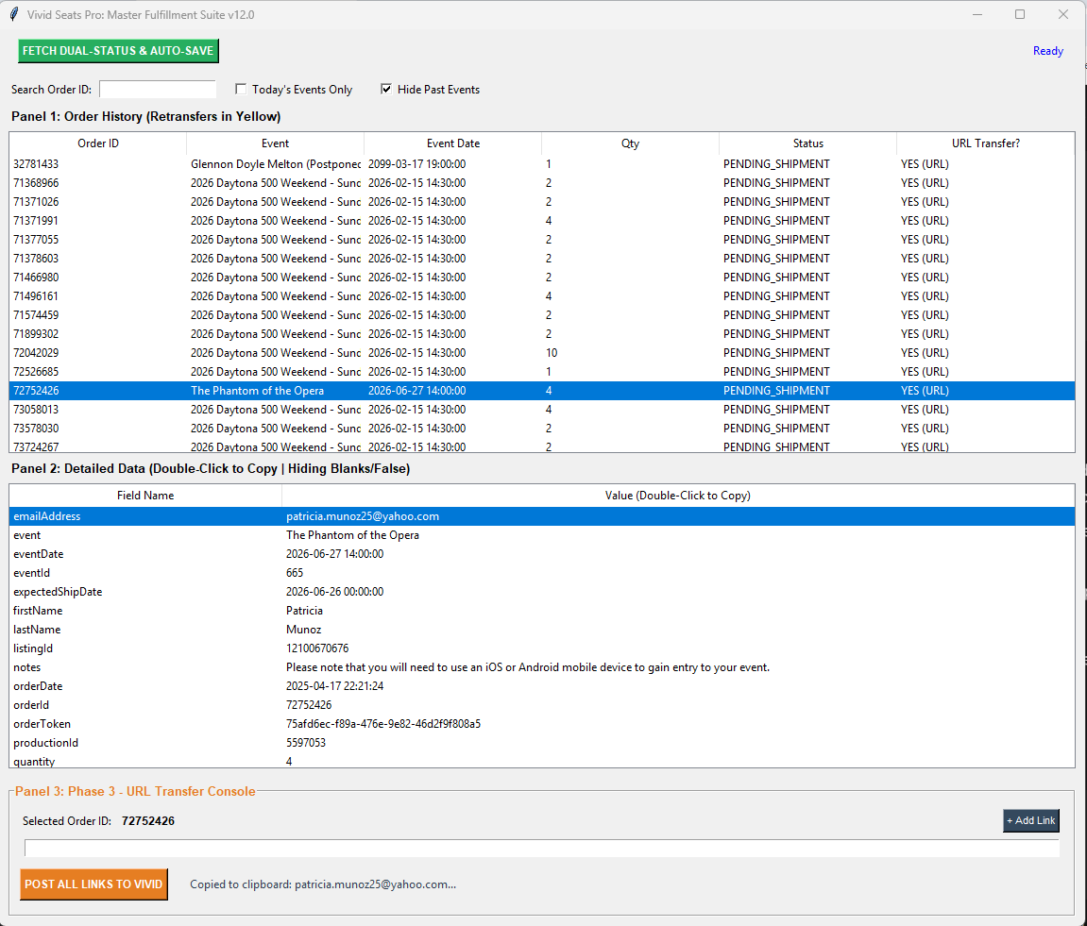
Calls API in real time, no rate limit
Pending Shipment
+
Retransfers (in Yellow) rate limit once every 60s
Allows for multiple links for single order

